Green Society Public School
Ratnanagar-7, Sauraha, Chitwan
Third Achievement Test-2082
Class: 2 Time: - 40 mins. F.M.: 20
Sub: Maths
Name: Roll No.: Sec.:
OBT.MARKS:
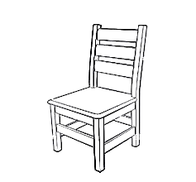
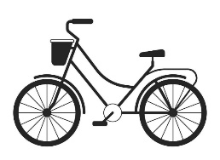
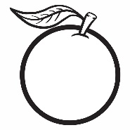

1. Put a tick (✓) mark on the objects that weigh more than 1 kg. (2)
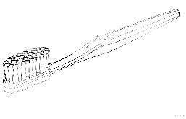

2. Add the following. (4)
KG | GM
1 0 | 3 5 1
4 0 | 1 2 0
KG | GM
9 5 | 8 5 9
2 5 | 1 1 5
3. Subtract the following. ( 4 )
KG | GM
9 5 | 1 1 0
2 6 | 1 0 0
KG | GM
8 0 | 5 1 0
3 0 | 1 8 0

4. Write the following in words. (4)
Ex: Rs 100.50= One hundred rupees and fifty paisa
Rs 50.50=___________________________________________
Rs 76.35=___________________________________________
Rs 721.45=__________________________________________
Rs 8.25 =__________________________________________
5. Look at the bar diagram and answer these questions. (6)

- How many children like coffee?________________
- How many items of hot drinks are there?___________
- How many children like milk more than tead?_________
- How many children like hot lemon?____________
- How many children like tea more than coffee?________
- How many children like milk?____________
The End

